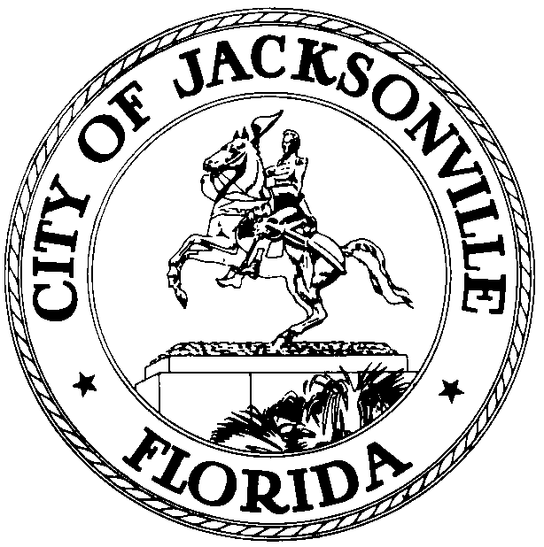

OFFICE OF THE CITY COUNCIL
RANDY DEFOOR
COUNCIL MEMBER, DISTRICT 14
PHONE (904) 255-5214
FAX (904) 255-5230 EMAIL: RDEFOOR@COJ.NET
117 WEST DUVAL STREET, SUITE
425
4TH FLOOR, CITY HALL JACKSONVILLE, FLORIDA 32202

20220609 Noticed Meeting CM DeFoor RE Public Transportation in Murray Hill
May 26, 2022
1:00 P.M.
Meeting Notice
Notice is hereby given that the Honorable Randle DeFoor, District 14 Council Member, hereby schedules a Town Hall for Thursday, June 9, 2022, 6:00 P.M. at Edgewood Avenue Christian Church, 1041 Edgewood Ave S, Jacksonville, FL 32205. The purpose of the meeting is to discuss public transportation in Murray Hill with neighbors, Jacksonville Transportation Authority, and the Murray Hill Preservation Association. This meeting is open to the public.
ADA and TDD ASSISTANCE
Pursuant to the American with Disabilities Act, accommodations for persons with disabilities are available upon request. Please allow 1-2 business days’ notification to process; last minute requests will be accepted, but may not be possible to fulfill. Please contact Disabled Services Division at: V- 904-255-5466, TTY-904-255-5476, or email your request to KaraT@coj.net.
For general meeting information or questions please contact Brooks Dame at BDame@coj.net
RD/bd
cc: Council Members and Staff
Margaret “Peggy” Sidman, Director/Council Secretary
Merriane Lahmeur, Chief, Legislative Services
Yvonne Mitchell, Chief, Administrative Services Division
Jeff Clements, Chief, Research Division
CITYC@COJ.NET
Electronic Notice Kiosk – 1st Floor City Hall
Public Notice System – City Council Web Page
Media Box
File Copy

